**COMPUTER SCIENCE II**

**JAVA GREENFOOT TEST #2**

**DATABASE CONCEPTS – CHAPTER 1 TEST**

**EACH QUESTION BELOW IS WORTH 2 POINTS. PLEASE ANSWER CLEARLY IN THE SPACE PROVIDED.**

**Jake Lorah**

1. A constructor is a special code that will be executed automatically whenever a new instance in a class is created. This code essentially sets up the new object for later use.
2. If a constructor is not written for a class, Java will generate a constructor automatically.
3. What is an access type? What is it used for?

An access type is the way you view the program. Access Types can be any of the following: public, protected (restricted people can see it), or private (just you can see it).

1. Name and describe 3 access types covered in class.

3 access types covered in class are public, which means anyone can access it, protected, which means only restricted people can see it, and private, which means only you can see it.

1. Explain the meaning of the term “programmatically”.

The term programmatically means directly from the code.

1. List the steps needed to create a new image object in Java.

To create a new image object in Java, First the image object is created from the image file. Next, GreenfootImage object is created. Then, the setImage method is called. Finally, the image object is passed as the method parameters.

1. The screenprint below shows two objects. In Java they are also called variables and like all variables they store information that can be used in the program.

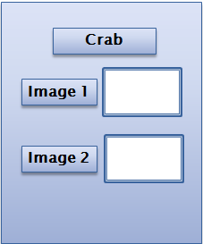

1. Describe the difference between world objects and actor objects.

Constructors of the world class can be used to initialize world objects. Likewise, the constructors of the actor class may be used to initialize actor objects.

1. Review the code sample below. What is it? What is it going to do?

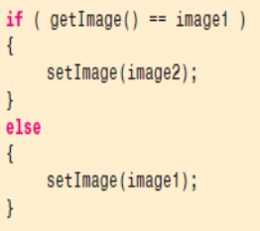

This is an IF/ELSE statement in Java. This will display image2 only if the current image is equal to image1. If not, image1 will just display.

1. Explain how Java assignment symbols are different Javascript assignment operators .

In JavaScript, variables were usually created without any values assigned by default. As previously discussed, data values were assigned to variables using assignment operators. However, Java uses special lines of code called assignment statements for this purpose. As a result, objects or values can be assigned to variables and stored there for later use. Assignment operators in Java are referred to as assignment symbols. Variables containing objects will always have a reference to that object.

1. According to the textbook, what is the key concept for understanding databases?

A key concept for understanding databases is to always make sure the data is organized within the database. You never want to mess up information.

1. The screen print below represents a database flow chart. What is it used for?

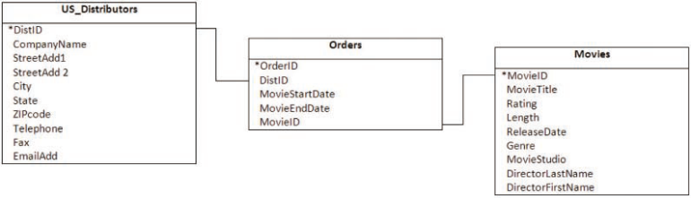

It is used to show the main structure of the database. Prototype.

1. Explain the difference between a record and a field.

A record is a collection of fields pertaining to a single entity such as a person, business, or place. A field is the most basic element of a database. It is a single piece of information that pertains to people, places, or objects.

1. Review the 4 icons below. Name the MS Access object that each one of them represents and describe its purpose.





The green notebook represents a report. The Square with the red line at the top represents a form. The two overlapping squares represent a query. And the table on the bottom right is a table. These are all objects. A report is the output based on the information found in database tables or database queries. A query can specify the data needed,e.g. records where the user is 21 or older. A form shows fields and records in a custom layout instead of the one in the datasheet. And a table is the basic database object. It allows for data to be organized data in fields and records (rows and columns). Tables are very important because they give you a place to store the data. Without tables, there would be no place to store any data.

1. Contrast and compare the concept of Cloud BI to traditional database computing methods. Name 3 advantages and disadvantages of each.

For cloud computing, instead of being accessible via physical hardware, all servers, software and networks are hosted in the cloud, off premises. So rather than investing money into purchasing physical servers in-house, you can rent the data storage space from cloud computing providers on a more cost effective pay-per-use basis. An advantage of cloud computing is it offers much more flexibility than traditional computing. The on-demand virtual space of cloud computing has unlimited storage space and more server resources. Disadvantage of cloud computing is it could cost more money.

1. What is a database administrator? Name any 3 daily tasks this person is responsible for.

A database administrator is a person who maintains and organizes databases. 3 tasks that he would be responsible for is organizing the data from a company into a database, updating the database with new information, and keeping the database secure form any hackers or such.

1. No database can exist without tables which are a collection of records made up of individual fields.

Also, without tables the other database table won’t be able to get any linked data.

1. The screen print below represents a database query. Name one of its benefits.



A benefit of using a query is it can specify the data needed, e.g. records where the user is 21 or older. Instead of looking through the whole database, you can just look for a certain property.

1. What does the acronym DBMS stand for? Name a DBMS covered in class.

DBMS stands for Database Management System. An example is Microsoft Access.

1. The screen print below represents the basic shell of Microsoft Access. Based on the 6 numbered boxes below, label all of its major components.

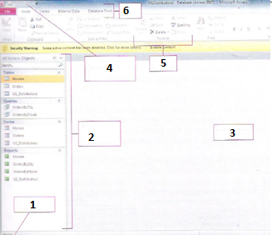

1. Add a new record
2. Tells you all of the objects you have created
3. The table, place to put data
4. Print preview, undo, etc…
5. Add new record, sort in ascending/descending, filter
6. Database tools
7. Describe the difference between macros and modules. Which one would you create/use at this point and why?

A Macro is a tool that automates repetitive tasks. Modules are advanced automation through programming using Visual Basic for Applications. I would use Modules because it would be more beneficial using advanced automation and make it pop out more.

1. To help you customize your data, MS Access has 4 different data views available for use. The pivot chart view can be represented by the charts while the datasheet view appears automatically. The design view allows you to change things like the name of the selected data type, however, you can only see the table element properties but not the actual data in this view.
2. Name and describe the controls found on the Records Navigation Bar. Where exactly is this tool located?

The controls found on the navigation bar allow you to search, move through the table record by record, skip records, add newrecords and apply filters. It is located at the bottom of the database.

1. You have been asked to create a database for the students in the AOIT Department at PCTI. Provide a detailed description of the steps you would follow as well as the fields, tables and any other objects/tasks that would be needed to successfully complete this project.

First ask yourself what is the database for and what information/data is needed for this database? Then create and name the fields for each table. Organize the data in tables. Each table needs a unique field to identify each record in the table. In the end, ask yourself which tables can be linked by a relationship?

1. What is an entity? Provide 3 examples of entities covered in class.

An entity is a single piece of information. 3 examples are a person, business, or place.

1. The screen print below is a snapshot of a database record. Name one of its benefits.

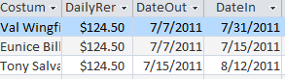

A benefit of using fields is that it pertains to a single person. No duplicates.

1. Name and describe the keyboard shortcuts that can be used to navigate through a record.

Page Down - Next record.

Page Up - Previous record.

Ctrl + End - Last field in the last record.

Ctrl + Home - First field in the first record.

1. Name and describe the keyboard shortcuts that can be used to navigate through a datasheet.

Home - First field in the current record.

End - Last field in the current record.

Tab - Next field in the current record.

Shift + Tab - Previous field in the current record.

Ctrl + Home - First field in the first record.

Ctrl + End - Last field in the last record.

1. You have a database table called CS2_2015 containing information about all of this year’s CS2 students. To see which students are eligible for the National Honor Society you would use a database object known as the query and based on this information you would produce a report for the NHS committee to review. To add new students to the roster you would use the new record button while to automatically compute each student’s shop GPA on the last day of each month, you would use a query.
2. List the steps needed to delete unwanted records from an MS Access database.

To delete records from a database, you can either right click on the record, and click delete record. You can also highlight it and press the delete button

1. The screen print below is a snapshot of a database form. Name one of its benefits.

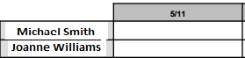

A benefit of using a form is you can organize it in the way you want it to look.

1. What is a primary key? Where is it found?

A primary key is the field by which the table is sorted whenever the table is opened. Each table must have one and it contains unique data for each record, e.g. ID number. It is used to uniquely identify a record. It is found in the Design View.

1. The screen print below represents an example of a database report. Name one of its benefits.

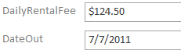

Benefit of using forms is it shows fields and records in a custom layout instead of the one in the datasheet.

1. According to CNN Money’s article “Best Jobs in America” which you have previously read, what is one of the disadvantages of being a database administrator? Based on your experience, propose a solution to this issue.
2. According to the Computerworld article “Cloud BI: Going where the data lives” which you have previously read, what is one of the roadblocks companies should look out for when considering cloud BI?
3. Name two ways of creating new records in MS Access.

To create new records in MS Access, you can use the datasheet view or form view. You can either just press enter to add a new record or click the play button with the star at the bottom of the database.

1. The screen print below represents an MS Access Pivot chart. Explain what it is used for.

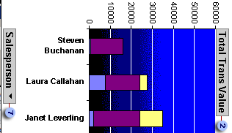

It is used to show the data in the database in a graphical manner.

1. Describe the process of updating an existing MS Access record.

You can easily modify existing records by selecting the one you want to change and clicking the pencil icon on the left or just double-clicking the record. Once you make the changes, simply move onto the next record and your changes will be saved automatically.

1. Name a major advantage of using MS Access for data maintenance.

MS Access gives you the basic shell for the database. Now all you have to do is fill in the information.

1. Describe the importance of using data in the field of e-commerce.

Data is so important because no company won’t be able to survive without the use of data. Data stores customer information, payment records, and important data for the company.